Running

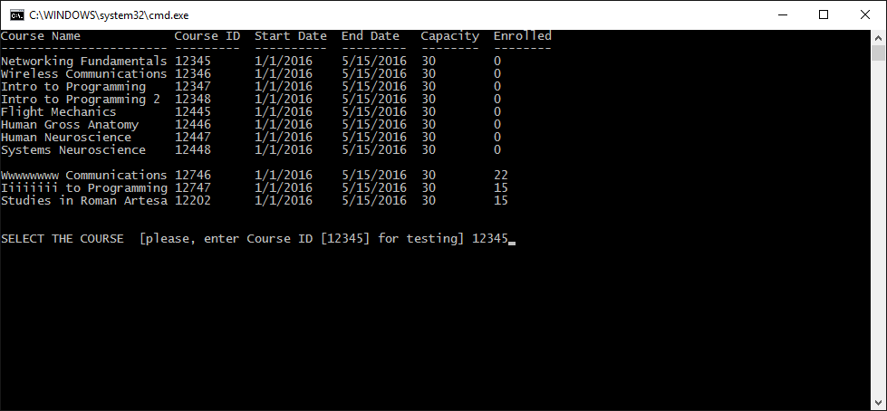

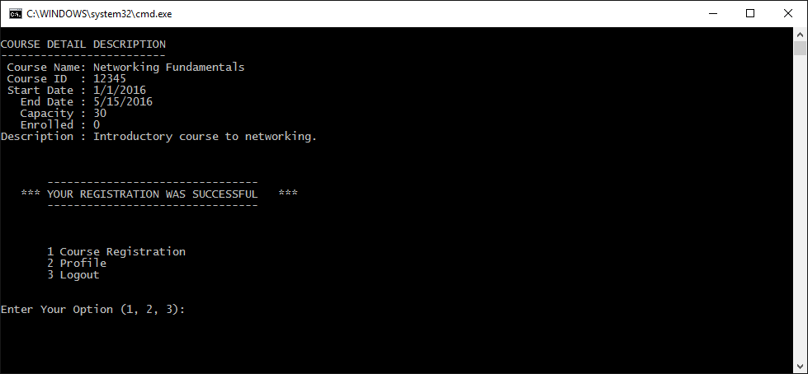

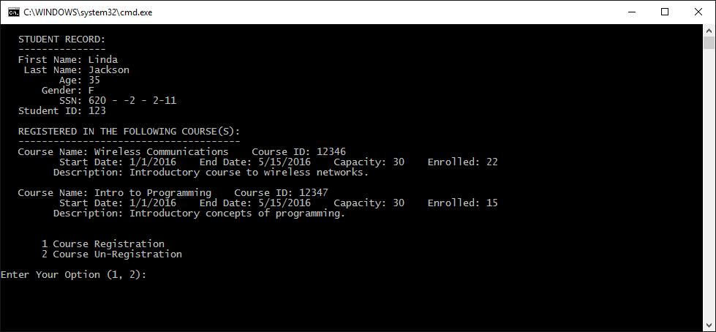

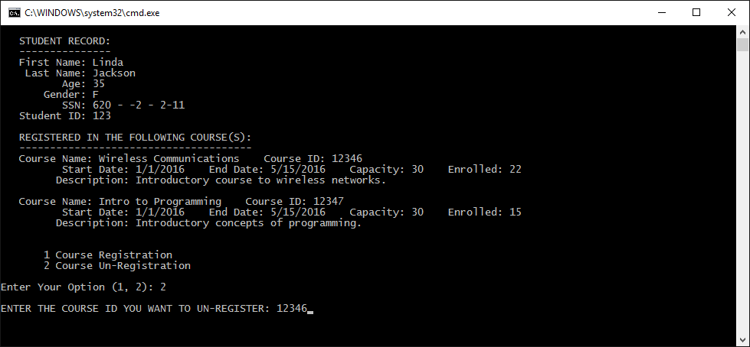

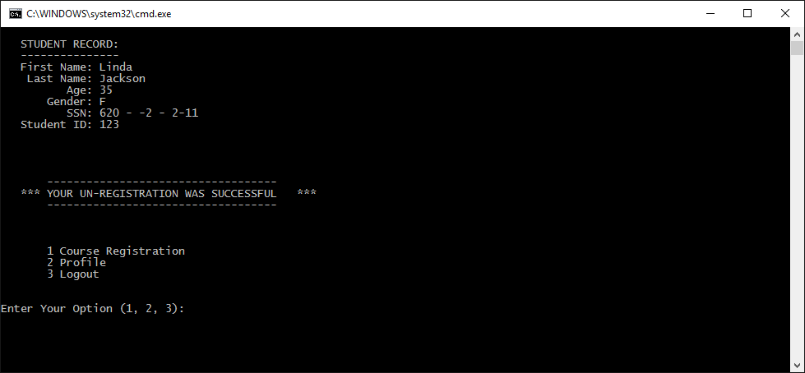

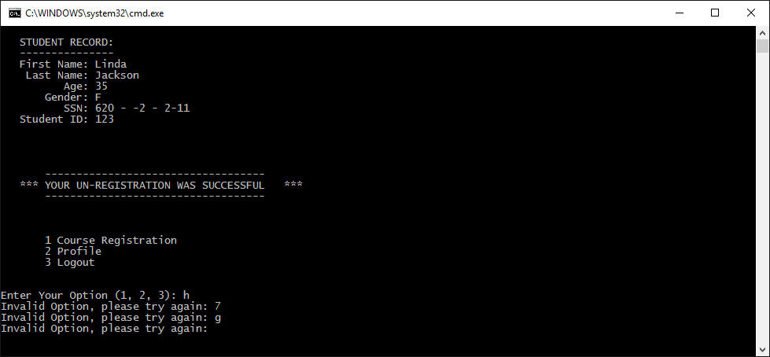

C:\Users\Cesar\Desktop\Team\_TeamA workIprogress\Code\readCourseState.java:13: error: cannot find symbol

for(Course course: courseList) {

^

symbol: variable courseList

location: class readCourseState

C:\Users\Cesar\Desktop\Team\_TeamA workIprogress\Code\readCourseState.java:24: error: cannot find symbol

boolean registeringCourse = registerCourse(courseID);

^

symbol: method registerCourse(int)

location: class readCourseState

C:\Users\Cesar\Desktop\Team\_TeamA workIprogress\Code\readCourseState.java:76: error: cannot find symbol

loginUser();

^

symbol: method loginUser()

location: class readCourseState

C:\Users\Cesar\Desktop\Team\_TeamA workIprogress\Code\readCourseState.java:81: error: cannot find symbol

if (registeringCourse) {

^

symbol: variable registeringCourse

location: class readCourseState

C:\Users\Cesar\Desktop\Team\_TeamA workIprogress\Code\readCourseState.java:128: error: cannot find symbol

loginUser();

^

symbol: method loginUser()

location: class readCourseState

C:\Users\Cesar\Desktop\Team\_TeamA workIprogress\Code\readCourseState.java:137: error: cannot find symbol

System.out.println(activeUser.toString());

^

symbol: variable activeUser

location: class readCourseState

C:\Users\Cesar\Desktop\Team\_TeamA workIprogress\Code\readCourseState.java:138: error: cannot find symbol

System.out.println(" Student ID: " + activeUser.getId() + "\n");

^

symbol: variable activeUser

location: class readCourseState

C:\Users\Cesar\Desktop\Team\_TeamA workIprogress\Code\readCourseState.java:140: error: cannot find symbol

ArrayList<Course> registeredCourses = activeUser.getRegisteredCourses();

^

symbol: variable activeUser

location: class readCourseState

C:\Users\Cesar\Desktop\Team\_TeamA workIprogress\Code\readCourseState.java:186: error: cannot find symbol

System.out.println(activeUser.toString());

^

symbol: variable activeUser

location: class readCourseState

C:\Users\Cesar\Desktop\Team\_TeamA workIprogress\Code\readCourseState.java:187: error: cannot find symbol

System.out.println(" Student ID: " + activeUser.getId() + "\n");

^

symbol: variable activeUser

location: class readCourseState

C:\Users\Cesar\Desktop\Team\_TeamA workIprogress\Code\readCourseState.java:189: error: cannot find symbol

boolean unRegisteringCourse = unRegisterCourse(courseID);

^

symbol: method unRegisterCourse(int)

location: class readCourseState

11 errors

Tool completed with exit code 1